MINISTRY OF ENVIRONMENT AND TOURISM
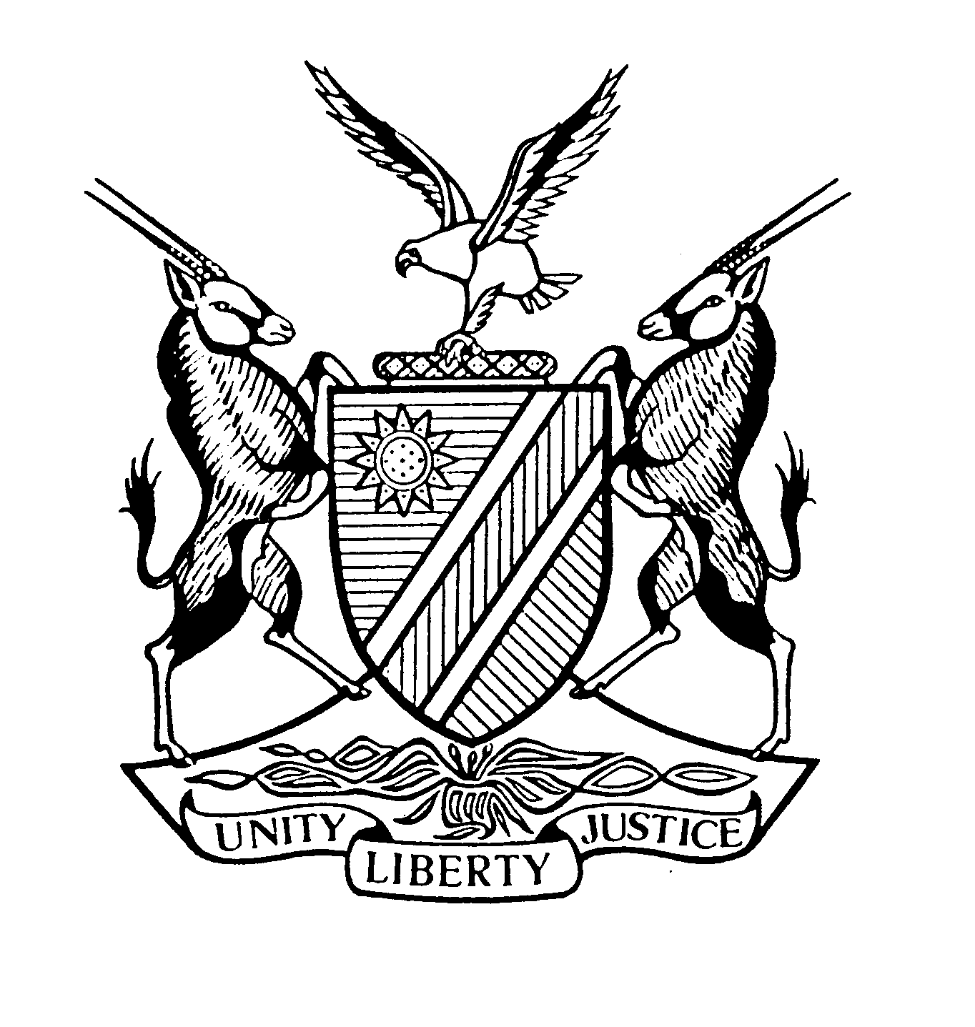
Private Bag 13306, Windhoek, Namibia

APPLICATION TO CONDUCT RESEARCH AND/OR COLLECT BIOLOGICAL SPECIMENS

1. PRINCIPAL INVESTIGATOR: (name, address, contact numbers):
To be submitted to the Permit Office, Ministry of Environment and Tourism at least 3 months before date of commencement of project.
Late submissions will not be accepted.

2. TITLE OF PROPOSED PROJECT:

◻ FULL PROPOSAL detailed protocol submitted at this time.
◻ PILOT PROPOSAL detailed protocol to be submitted after fieldwork begins.

3. PERIOD OF STUDY:

4. DATES OF FIELDWORK: _______________________________________________

5. LOCALITY OF PROPOSED RESEARCH
_______________________________________________________________________
For official use:

Deputy Director of Scientific Services

recommended/not recommended

Signature: Date:
Director of Scientific Services

approved/not approved

Signature: Date:

6. PARTICULARS OF ALL CO-WORKERS WHO WILL ASSIST YOU IN NAMIBIA
Name | Nationality
Attach list if necessary

I hereby certify that the information included in this application is correct. Moreover, I have read and understand the conditions and I agree to abide by them.

Signature of the Principal Investigator:

Place: Date:

Recommendation by research committee, head of institution, or employer of principal investigator:
I
Recommend the project proposed by the principal investigator in my
Capacity as

Signature: Date:

PLEASE APPEND TO THE APPLICATION:

1) Curriculum vitae of principal investigator, including a list of publications for the past five years.

2) A detailed description of the proposed research. Please pay special attention to:
a) Objectives, motivation, key questions and hypotheses to be tested. Differentiate between short and long-term studies.
b) Describe and discuss previous related research by yourself.
c) Discuss your approach to the study, and especially the methodology.
- Motivate species and numbers of biological specimens to be collected.
- Provide detail of assistance required from MET (keep this to a minimum).
- State clearly when collected specimens will be deposited in which collection (see below).
3) Letters of support from local institutions i.e. if you intend to collect animals you must provide a letter of support from the National Museum of Namibia, for plants a letter of support from the National Botanical Research Institute is required etc. Work in protected areas (parks) requires special motivation and a letter of support from the park warden.

GENERAL CONDITIONS:

- Please liaise with local institutions/authorities in your same field of interest.

- When appropriate, please supply a copy of your field catalogue of specimens collected to the Ministry of Environment and Tourism's Permit Office before leaving Namibia.

- Plant specimens should be deposited with the National Botanical Research Institute, palaeontological specimens with the Geological Survey, and animal, archaeological and anthropological specimens with the State Museum of Namibia. Alternative arrangements must be fully motivated for in advance and supported by a letter to that extent from the relevant local institution. Type specimens of new species and at least 30% of all secondary types must be deposited with either the National Museum of Namibia or the National Herbarium irrespective of when these species are described.

- Two copies of every publication (including theses) resulting from your research in Namibia, should be sent to the Namibian organisation under whose auspices you worked and the Ministry of Environment and Tourism Permit Office.

- Please advise the Permit Office before any changes are made in the scope of research or persons involved.

- If your work requires the export of specimens you must apply for a separate export permit from the Ministry of Environment and Tourism. Please note that other conditions such as CITES permits and veterinary clearance may apply.

- Foreign citizens conducting research in Namibia need to obtain other necessary documents. A "work visa" is required to conduct research in Namibia for a period of 3 months or less, and if over 3 months, a "work permit" is required. Application must be made timeously to the Ministry of Home Affairs, Private Bag 13200, Windhoek, Namibia. It is the applicant's responsibility to make these arrangements.

- Please forward your application together with all relevant documents to Mr. Timoteus Iita Matheus, Directorate Scientific Services, Ministry of Environment and Tourism, Private Bag 13306, Windhoek, Namibia, fax +264-61-2842832, email: imatheus@met.na.

- INDEMNITY: Any person entering or being in any part of Namibia for the purpose of research does so at their own risk, and the Government accepts no responsibility for damage, injury or death resulting from the presence or activities of such a person, or of the persons under their care in Namibia.

